STALL BOOKING & EXHIBITION CATALOGUE FORM

PLEASE FILL THE FORM IN ENGLISH (CAPITAL LETTERS) ONLY.

* Required Field
COMPANY NAME: *
FULL ADDRESS WITH
POSTAL CODE: *
CITY
STATE:
COUNTRY:
TEL:
MOBILE: *
E-MAIL 1:*
E-MAIL 2:
WEBSITE:
MANAGING DIRECTOR / CEO:
MARKETING MANAGER:
CONTACT PERSON: *
COMPANY DESCRIPTION:
(UP TO 30 WORDS)

NOTE: Company Profile received after deadline date will not entered in the Exhibitor Catalogue.

Date & Venue: _______________________________________________________________________

Hall No: -____________ Stall No: -___________ Size of your Stall (in Sq. mtr):-___________________

* Name of the Company / Organization, for Name Fascia Board: - (English Alphabet Only).

*Your Company Logo (to link in Exhibition website)
Please Attach Your Company Logo here or Attach in Email with this filled form.

* Memento Name / Certificate Name: -

* Exhibitor Badges
• Please Email a separate sheet if space given is insufficient.

Sr. No. | Company Name | Exhibitor’s Name | Designation | CELL NO | EMAIL ADDRESS

Note: Exhibitors badges names not received by the deadline date may cause delay on site in receiving the badges.

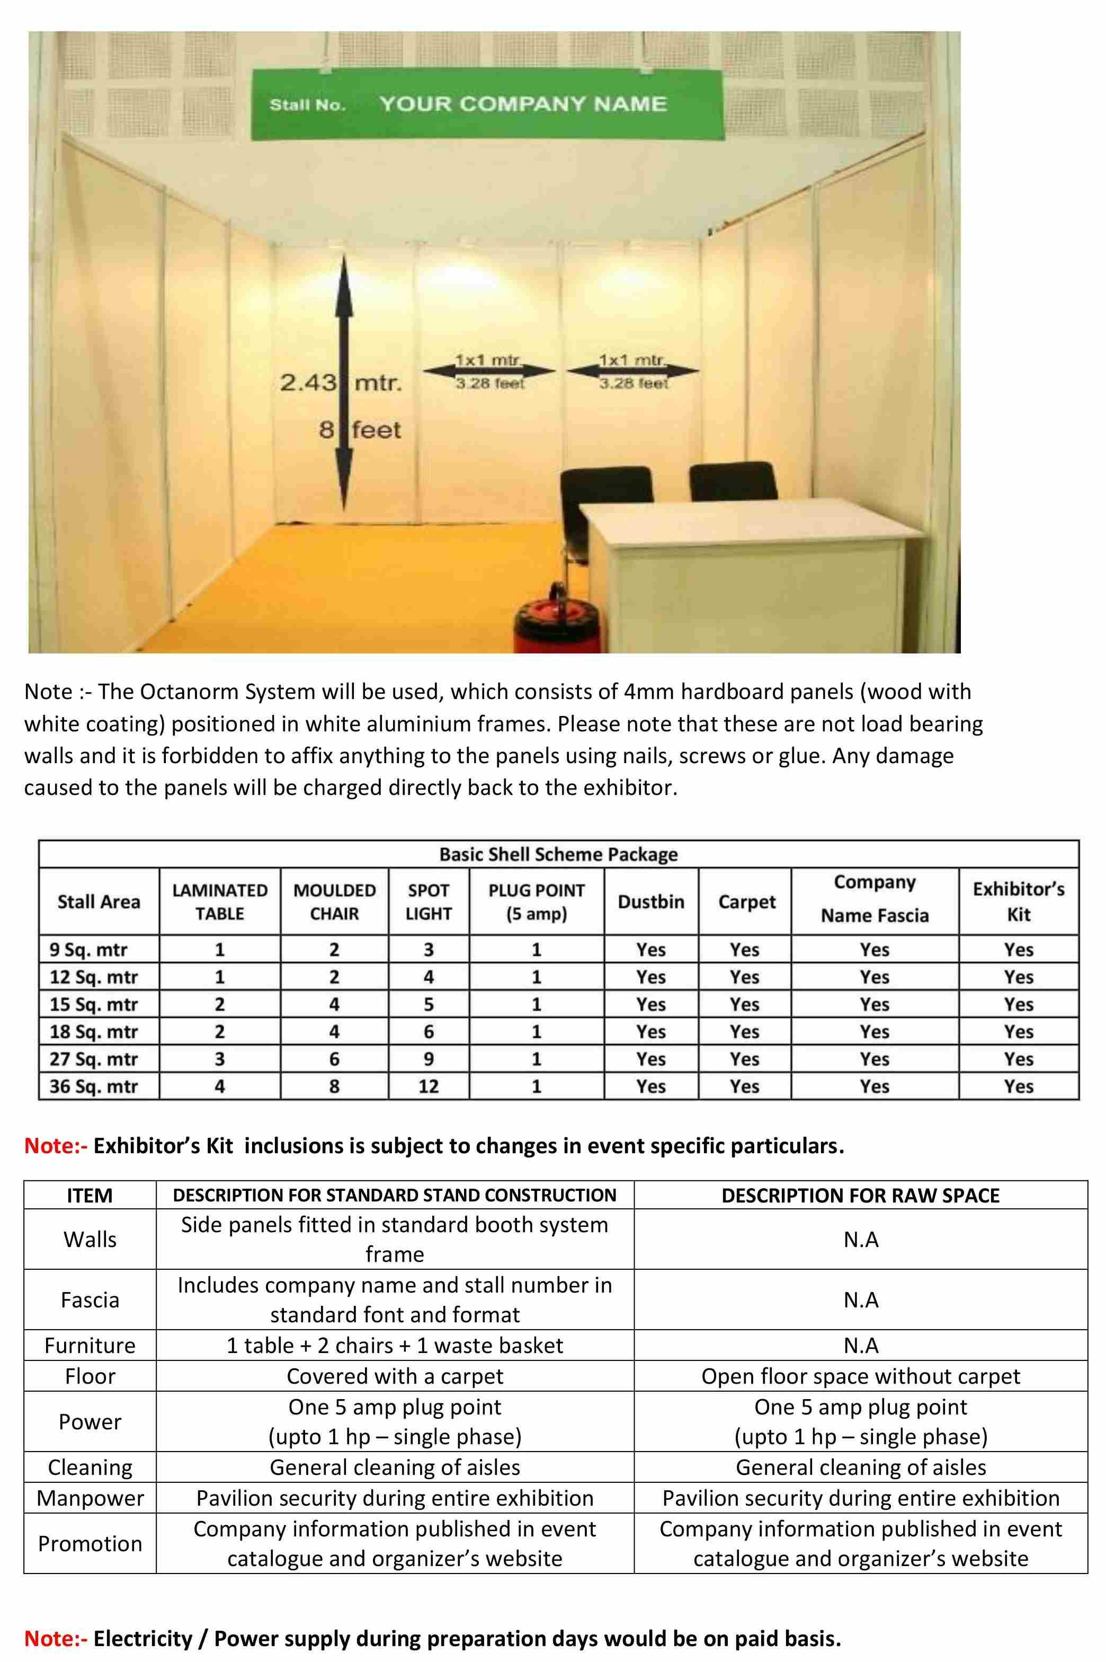

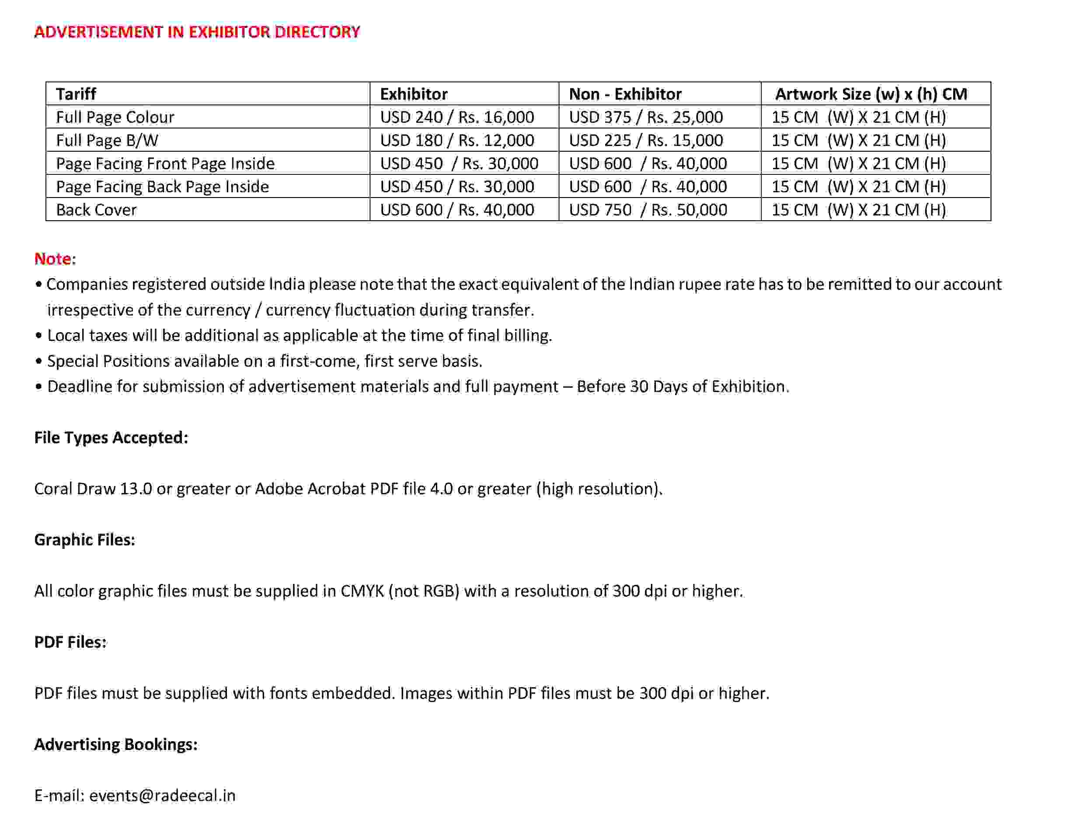

PARTICIPATION CHARGES
STALL TYPE (Please Select any one) | Standard Stand Construction / Raw Space
STALL SIZE | ___Sq. Mtr
AMOUNT | _______________ INR / USD / (Any other Please Specify)
Total Amount with Service Tax:

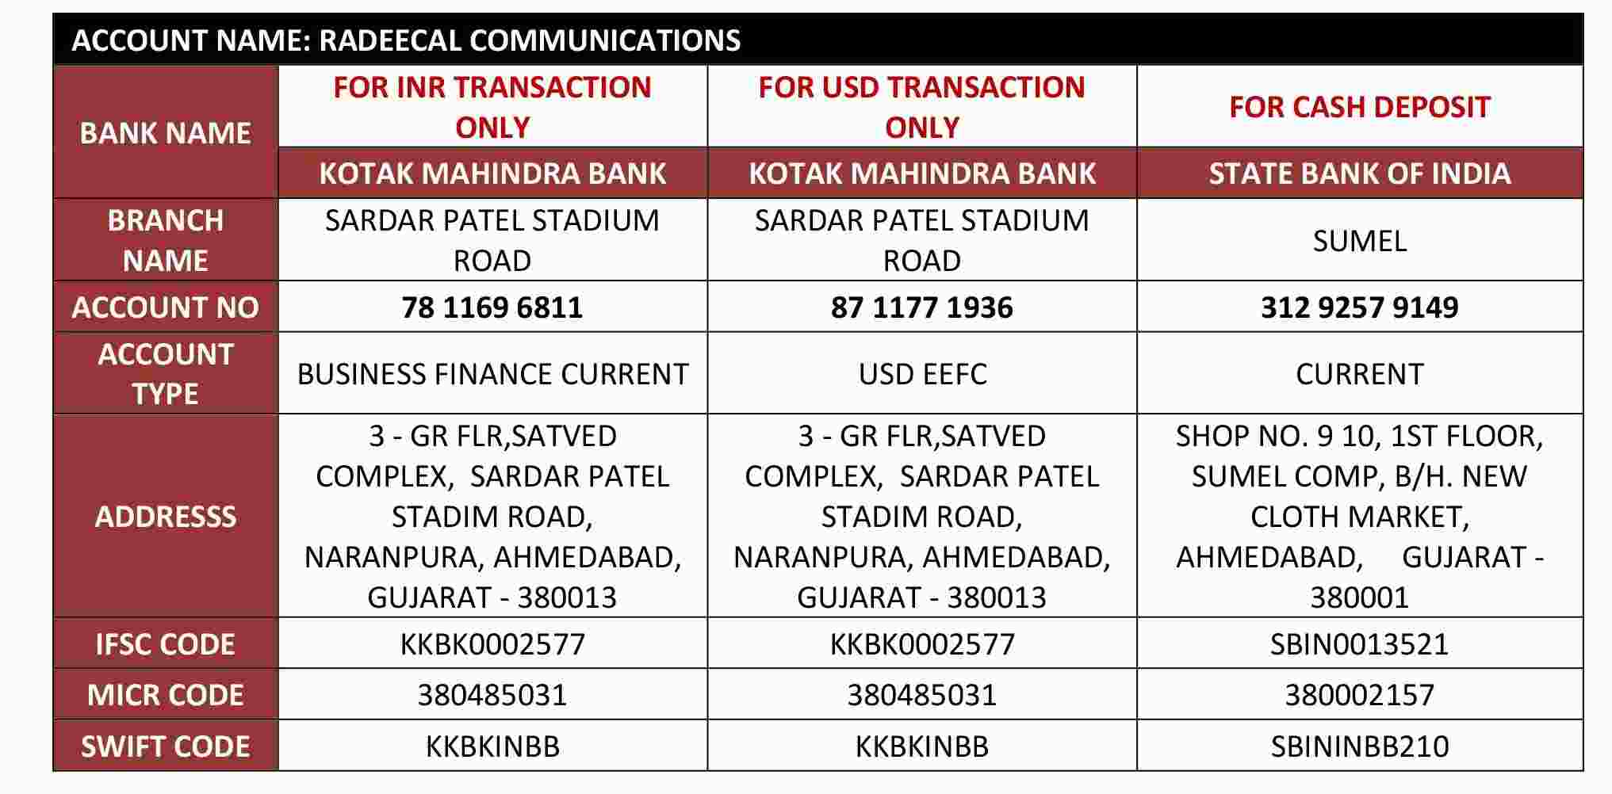
BANKING DETAILS:-

Note:
- Kindly use following priority
1) Kotak bank account
2) State bank of India

- For International transaction use Kotak bank USD EEFC Account only
- While Payment Process, Please Mention that all bank charges to be borne by PAYER.

PAYMENT SHOULD BE MADE IN FAVOR OF “RADEECAL COMMUNICATIONS”
We have read the terms & conditions mentioned overleaf and agree by the same In the case of counter sale.
The payment of sale tax as applicable to the concerned Authorities will be the direct responsibility of the exhibitors. Service Tax will be charged extra as per existing norms.

